Metropolitan State University, Saint Paul, Minnesota

ICS 140 Computational Thinking with Programming

Assignment 3

For the problem below, complete the following steps:

* Create test cases with expected results based on example input
* Create Python Code
* Show Test Results

Write a program to calculate compound interest. When a bank account pays compound interest, it pays interest not only on the principal amount that was deposited into the account, but also on the interest that has accumulated over time. Suppose you want to deposit some money into a savings account, and let the account earn compound interest for a certain number of years. The formula for calculating the balance of the account after a specified number of years is:

$$A={P(1+ \frac{r}{n})}^{nt}$$

The terms in the formula are:

A is the amount of money in the account after the specified number of years.

P is the principal amount that was originally deposited into the account.

r is the annual interest rate.

n is the number of times per year that the interest is compounded.

t is the specified number of years.

Write a program that makes the calculation for you. The program should ask the user to input the following:

* The amount of principal originally deposited into the account
* The annual interest rate paid by the account
* The number of times per year that the interest is compounded. (For example, if interest is compounded monthly, enter 12. If interest is compounded quarterly, enter 4.)
* The number of years the account will be left to earn interest

Once the input data has been entered, the program should calculate and display the amount of money that will be in the account after the specified number of years.

You can use an online calculate like this one to compare the results of your program and create test cases: <https://www.thecalculatorsite.com/finance/calculators/compoundinterestcalculator.php>

Record your test information in this file and upload your python file separately.

**Test Case 1**

**Example Input**

P = 1000

R = 0.05

N = 12

T = 10

**Expected Result:**

Total = $1647.01

**Actual Result**

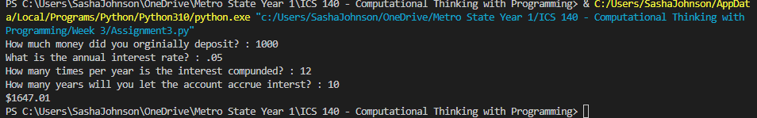

**Test Case 2**

**Example Input**

P = 3580

R = 0.12

N = 12

T = 20

**Expected Result:**

$38,995.34

**Actual Result**

**Code:**

